COMBINED CYCLE POWER PLANT
Student Name
Institution
Course Name/Number
Due Date
Instructor Name

The combined cycle power plant (CCPP) consists of gas turbines and engines that convert the heat to mechanical energy. The system operates on the same design concept as that used with the marine propulsion, which because of the combined thermodynamic cycles, improves the system’s efficiency while optimizing the cost. It operates based on the idea that when the working fluid comes from the first engine, it goes to the second one that extracts this energy through the heat exchanger. This power generation idea of two multiple works steams increases the efficiency to a value between 50 and 60%.
Thermodynamic cycles of this system are the Rankine made of the steam turbines & Brayton cycle consisting of gas turbines resulting to a-b-c-d-e-f-a and 1-2-3-4-1 sequence respectively. Heat transfer in this system from the exhaust gas with higher temperatures to steam and water occurs by a waster-heat recovery boiler system in the bottom cycle. The consistent pressure process of exhaust gas in gas turbines results in the rejection of heat.
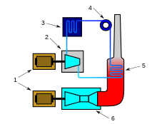
Figure showing the combined Cycle power plant were 6 (Gas Turbine), 5 (Heat exchanger/ Boiler, 4(Pump), 3( Condenser), 2(Steam Turbine), and 1( Electric generator).
This system offers several advantages, including capital expenditures, efficiencies, water requirements, self-sustainability. For instance, the combined cycle power plant has an efficiency between 40-50% higher than those of steam & turbine types; it also offers a higher flexibility in the shut-down and starting operations because of its ability to accept variations in loads abruptly that gives better stability with the electrical grid. Unlike conventional steam turbines, the combined cycle offers a much lower cooling water requirement regardless of the same power generation capacity. The ratio of the power output with the area is also higher, making it compact in the installation site. Since the system has an integrated approach made of two complementary parts, the gas turbine, and steam power plants, it has an optimized architecture that reduces the down-time (maintenance duration). Other advantages of this system include
- Less solid wastes
- Lower operational costs.
- Environmental-friendly; it consumes fewer fossil fuels because of its efficiency, which reduces the gas emissions for each MW of generated electricity.
The combined cycle technology offers more tremendous advantages, especially by supporting large-scale power generation. Such systems composed of the gas turbine and the steam power plant produce 300MW of power; the installed capacity in the U.S is 1084GW; thus, it supports 27% of the total energy (Energy Information Administration, 2020). A combined cycle power plant can complement other energy sources such as Solar with 2.3%, Wind with 8.4%, Coal with 19.3%, Natural gas with 40.3% (Energy Information Administration, 2020).
The multi-criteria analysis is the best approach of selecting the engines in this combined power cycle system because of its ability to factor in the economic and technical factors. CCPP works with the intercooler (IC), regenerative cooling (RC), and regenerative heating (RH) sub-processes, the criteria, Bayton Cycle, accounts for these processes and calculates the weighted factors that explain the performance for each alternative. An ideal engine with the highest score for all criteria and the most feasible for the successive evaluation stages.
Table 1: Acceptance criteria for design aspect in this CCPP
Aspect | Explanation
Sale Policy | Economic Aspect
Maintenance | A period when there is downtime.
Exit mass Flow | Amount of steam/air passing out of the CCPP in a given time (in kgr/s).
Off design performance | Technical aspect
Availability/Reliability of gas turbines | Turbine Entry Temperature
Boiler pressures | Indicates the cost, design complexity
Gas Turbine Efficiency | Relevant when the steam-power plant is under maintenance
Cost | Size of plant-based on complexity and layout.
Efficiency | Affect the plant’s profitability

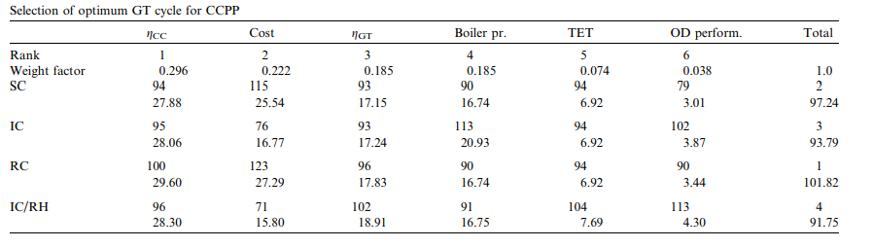
Figure showing the optimal Gas Turbine for the Combined Cycle Power plant (Polyzakis, Koroneos, and Xydis, 2008)
CCPP system is a design calculation aim to improve the overall efficiency consisting of the steam cycle efficiency and steam power output. Some of the factors include the steam dryness fraction, optimal condenser pressure, boiler pressures, superheated steam temperatures, isentropic efficiencies, gas temperature, and evaporator pinch points. The formulas involve include
$$ɳ_{CCPP}=\frac{{Output Work}_{Combined Cycle}}{{Heat Input}_{Gas Turbine}}………….where CCPP=Combined Cycle Power Plant$$
$$ɳ_{CCPP}=\frac{Net Steam Turbine work+Net Gas Turbine Work}{Fuel input Energy into Gas Turbines}$$

$$T_{m}=\frac{EGT+T_{stack}}{2} where T_{m}=Average boiler gas temperature$$
$$C_{P}=1020+420*e^{\frac{800}{T_{m}}}……. where T_{m}=Average boiler gas temperature C_{P}=average Specific Heat capacity,$$
The system’s thermal efficiency is the ratio of the output work and the heat input indicating for optimal scenario there should be less heat introduced as steam enters the system while more output power is generated. The fact that work output rapidly decreases compared to the heat input results in reducing thermal efficiency. Therefore combining the gas and steam cycles gives the graphical output below at different altitudes and ambient temperature.
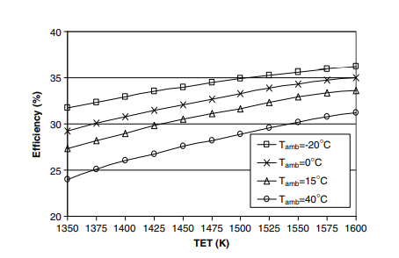
Figure showing the Efficiency variation with the Ambient temperature.
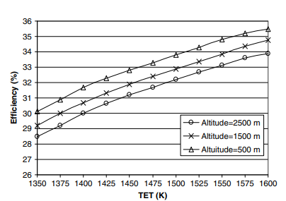
Figure showing the Efficiency variation with the Altitude.
This combined Cycle Power plant (CCPP) has great feasibility with the electrical performance through its large-scale power generation. Its superior performance also presents an alternative for the optimization scheme to support future versions of the combined cycle. This system has a theoretical efficiency of 53.5%, with an 8.0% wetness fraction, 13% acceptable limit that makes it viable for longer installation life. The power generated of 307.7MW contributes to 27% of the current United States installed capacity making it the second-best viable alternative after natural gas, higher for alternatives such as Solar and Wind.
REFERENCES
Energy Information Administration (2020). The United States. Independent Statistics & Analysis. Electric Power Manual. Accessed on 19th May 2021. Retrieved from Electric Power Annual 2019 - U.S. Energy Information Administration (eia.gov)
Polyzakis, A. L., Koroneos, C., & Xydis, G. (2008). Optimum gas turbine cycle for combined cycle power plant. Energy conversion and management, 49(4), 551-563.
Xu, F., Goswami, D. Y., & Bhagwat, S. S. (2000). A combined power/cooling cycle. Energy, 25(3), 233-246.

